Download and unzip the "World Wide Importers.zip" compressed file from Canvas under Week #6 folder. Store the spreadsheets in a folder on your local hard drive. Please remember this location as we will be using these files in several assignments. Open up Power BI and do the following:

Home > Get data > Text/CSV > drill-down to find and select FactSale.csv

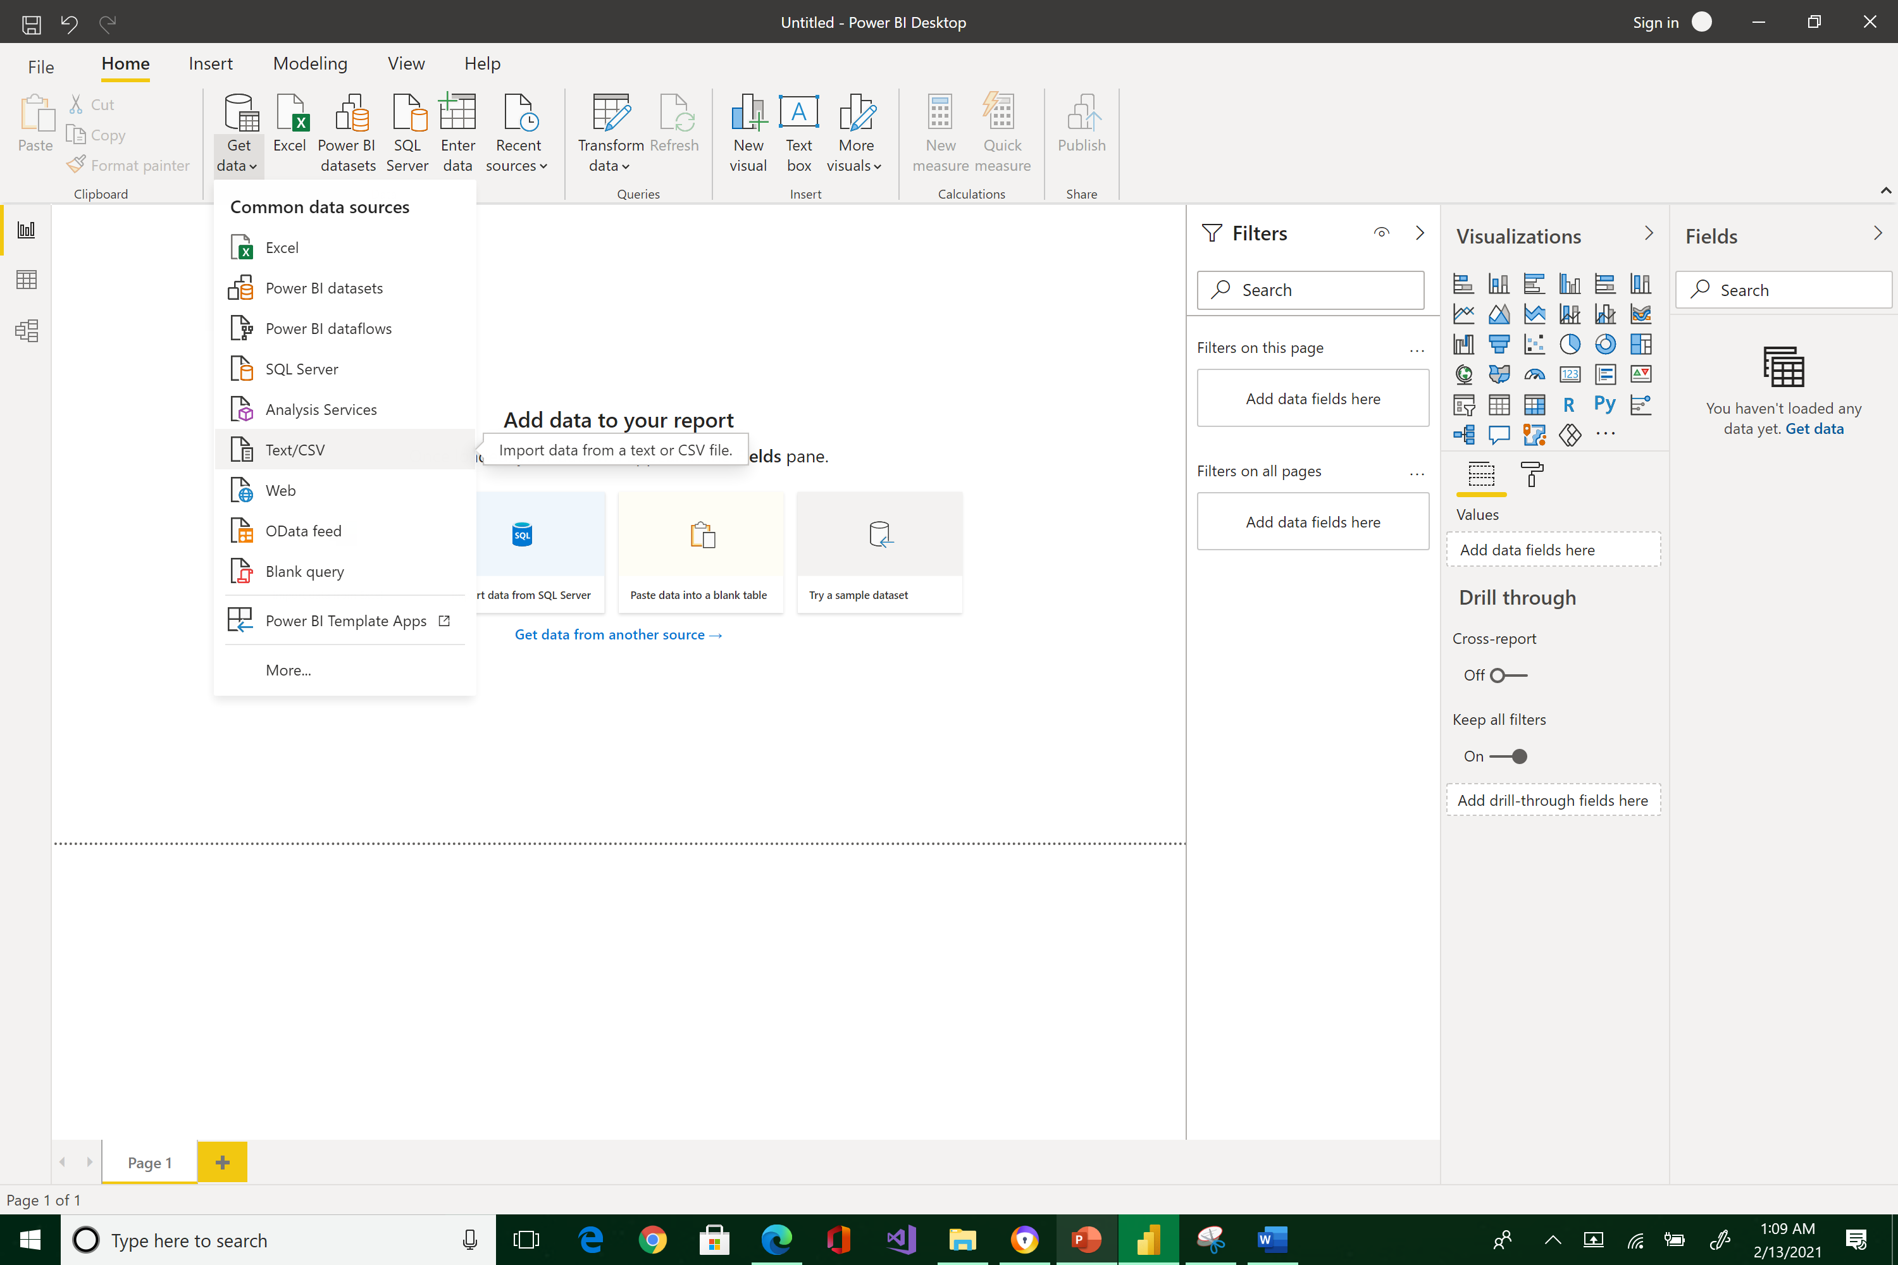



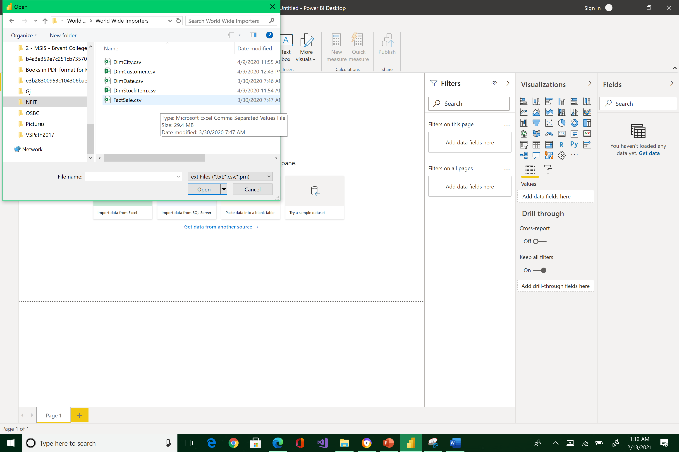



It will preview your data, click Load

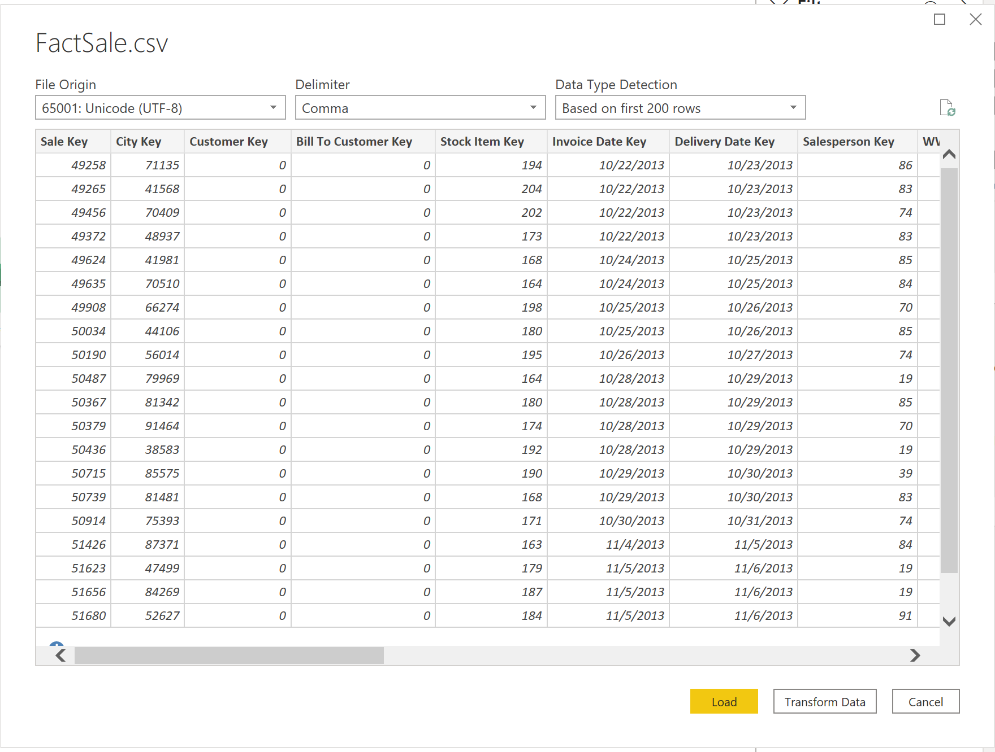



You will see a yellow bar warning about a pending operation. Ignore the message because it will soon go away.

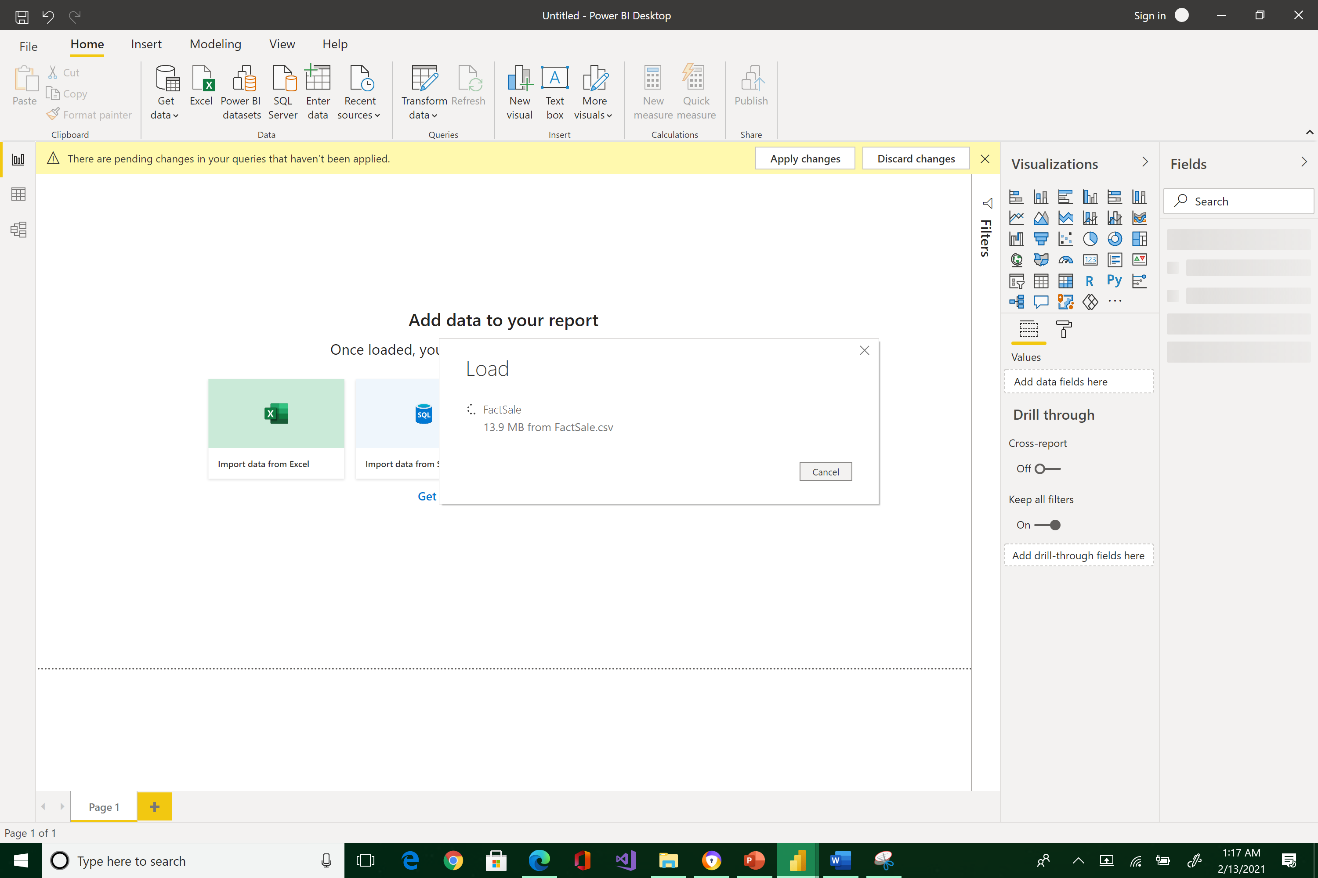

When the importing process is completed, you will see all the FactSale transaction table fields in the Fields pane.

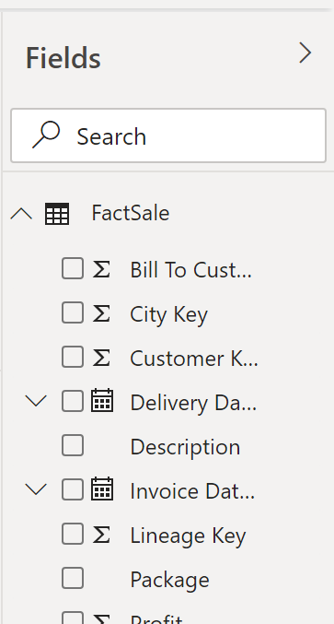



Select the field Total Excluding Tax

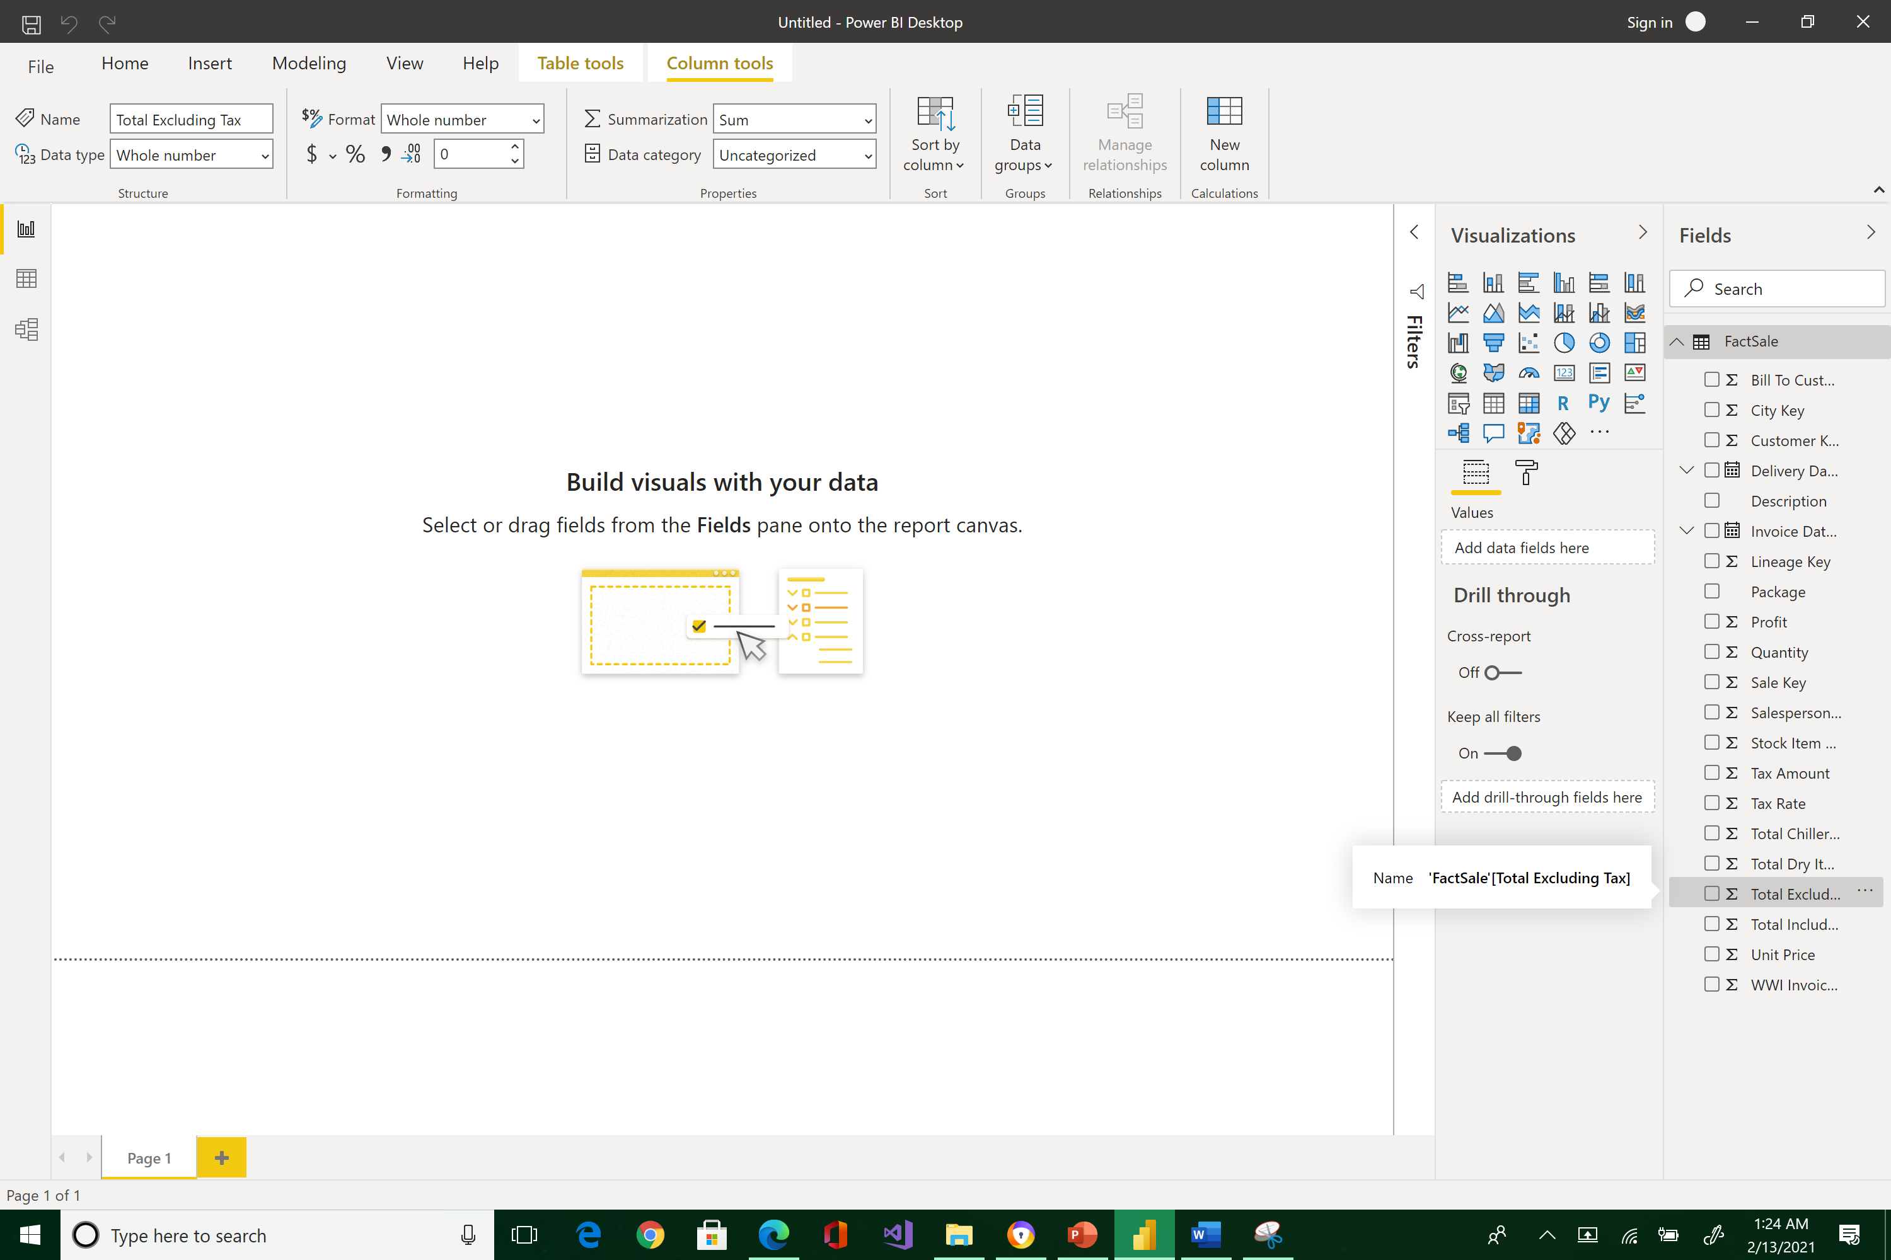 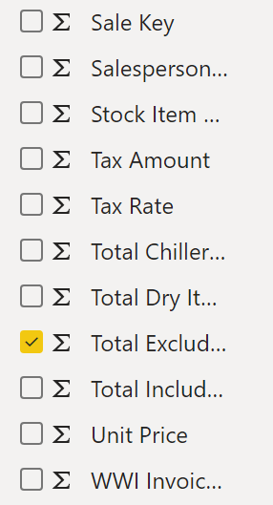



Power BI is automatically creating a bar chart in the Report's visualization Canvas.

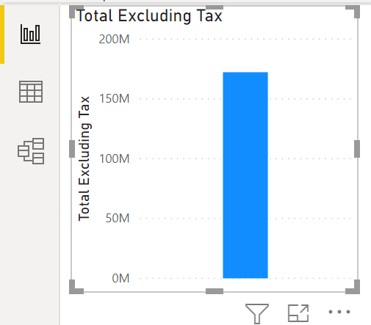

Power BI automatically recognized the field selected as a numerical field and added it to the Visualization pane's Values region.

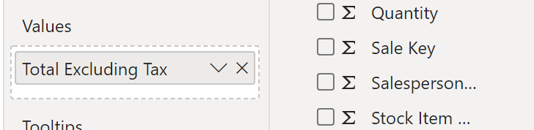



You can move and resize the bar chart easily by dragging it.

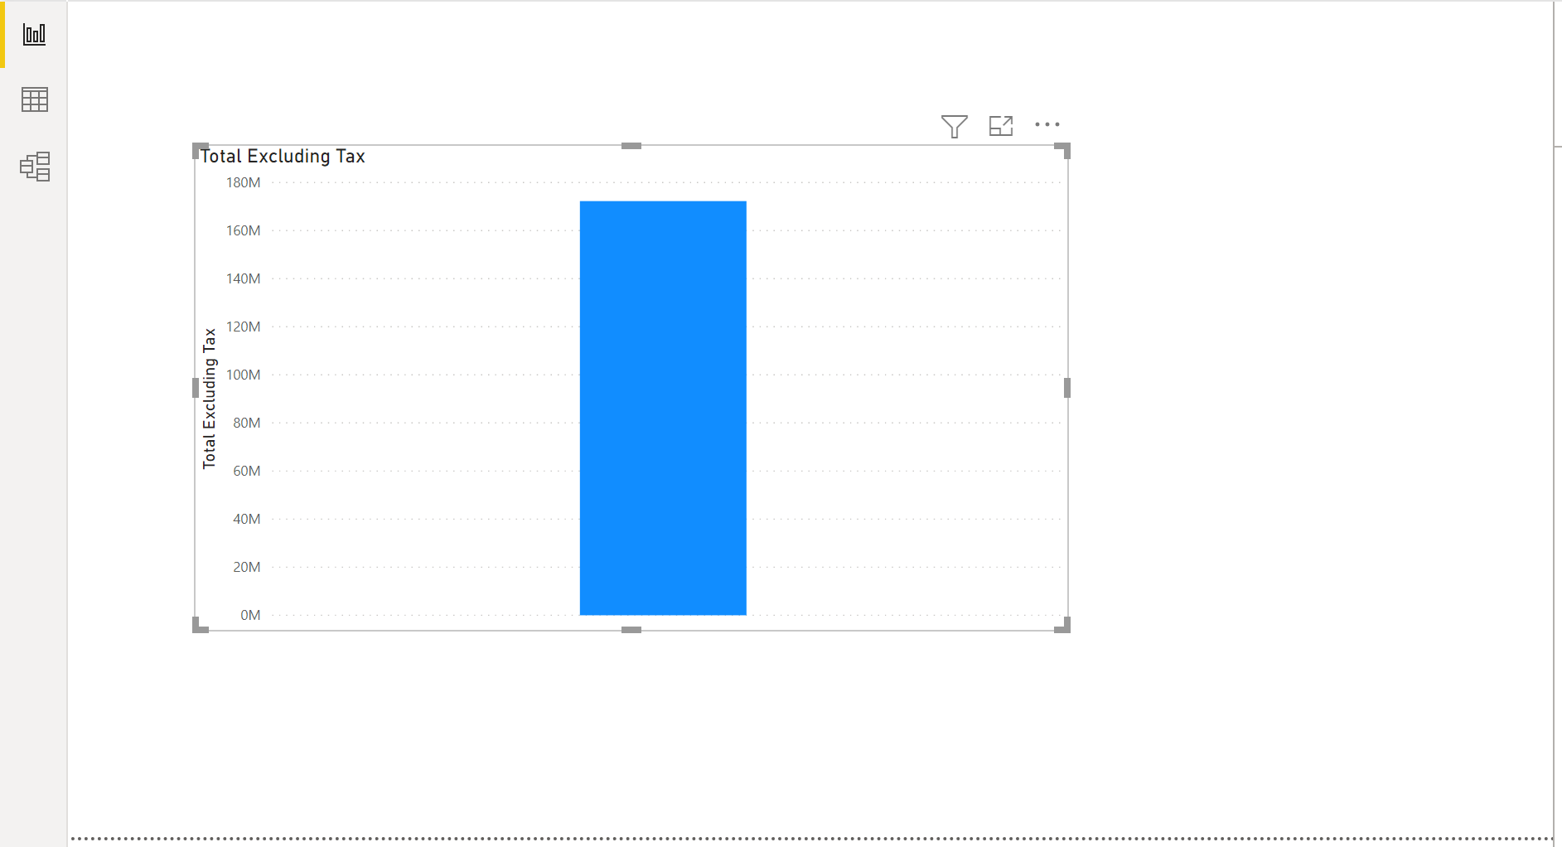

Switch from the Report View to the Data View to examine the raw data.

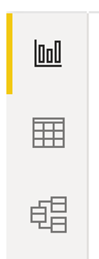



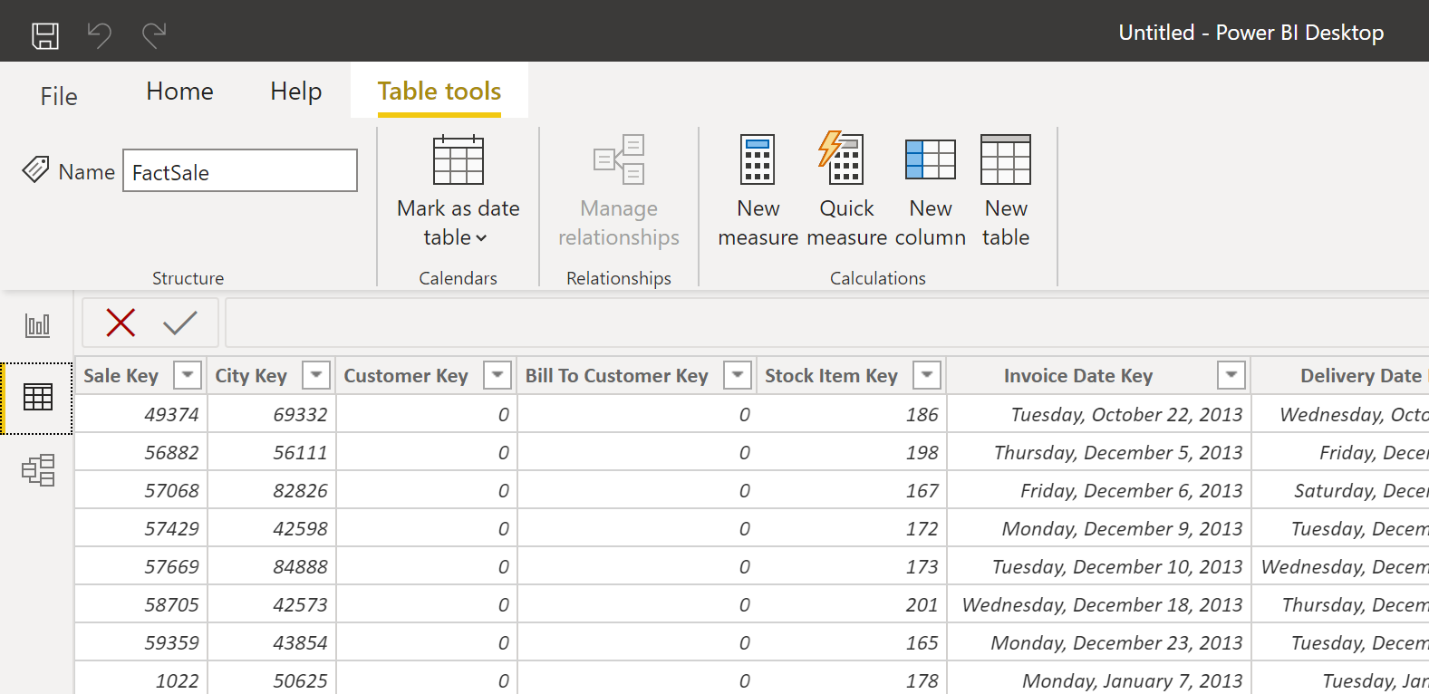



Note the different foreign keys; for example, Salesperson Key column.

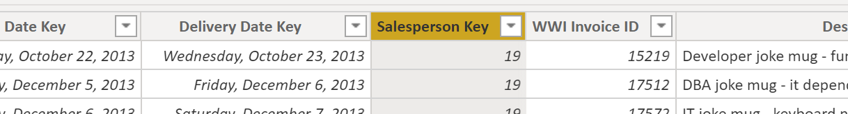

Load the associated lookup table called DimEmployee.xlsx, an Excel file (not a CSV file). So, be careful with the steps when you are loading this file.

Click the Home tab > Get data > **Excel** > DimEmployee.xlsx > and click Open

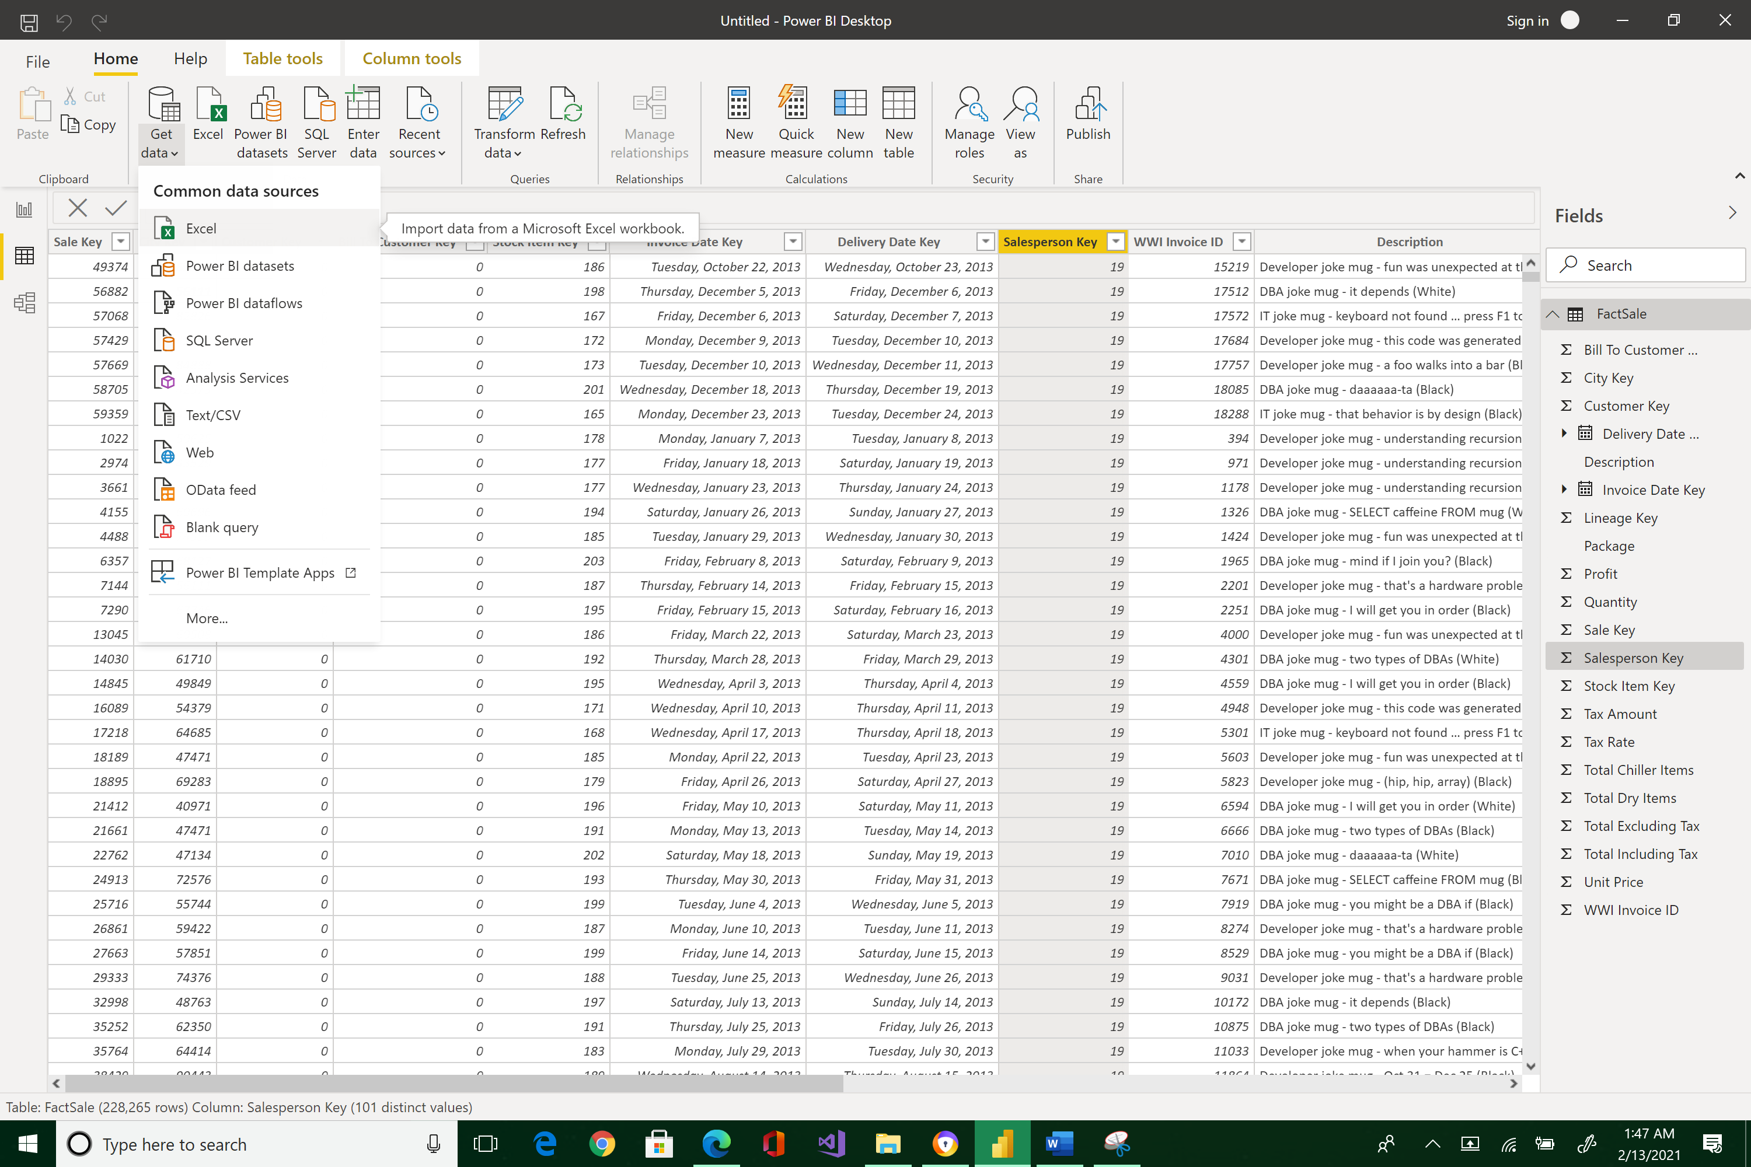 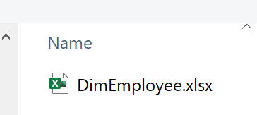



Select DimEmployee and Load it

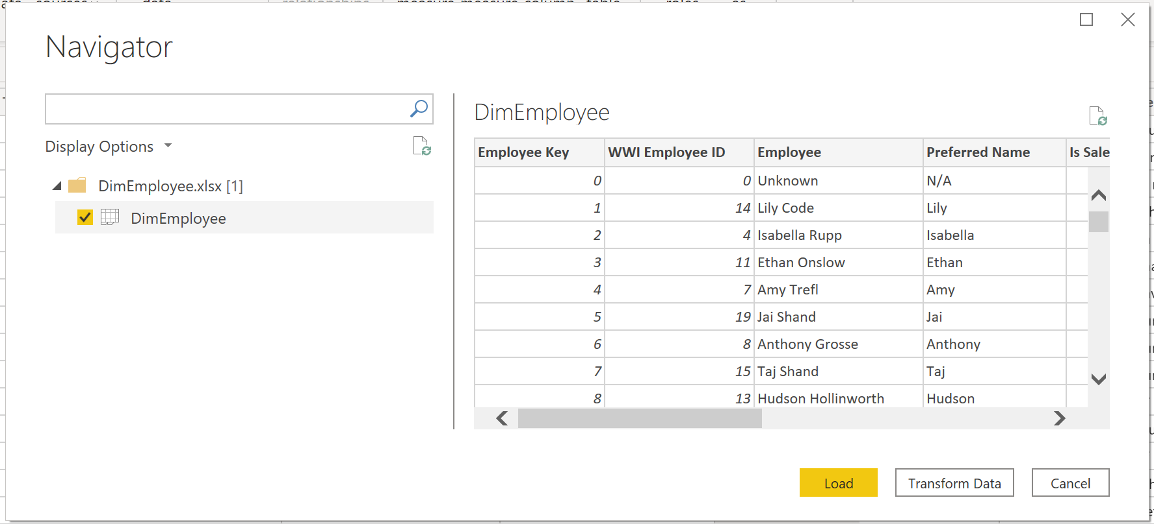



Observe that the new table is loaded and visible under the Fields pane.

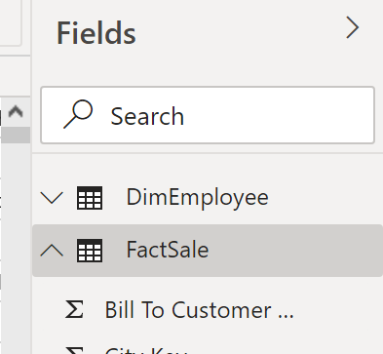



Click on the DimEmployee, and take note of its field called Employee Key

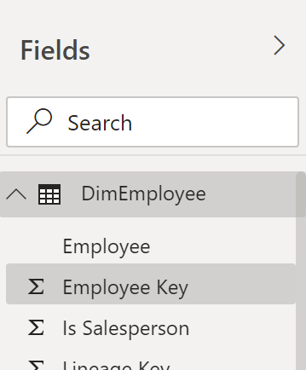



The Data view is now displaying the newly imported Excel spreadsheet.

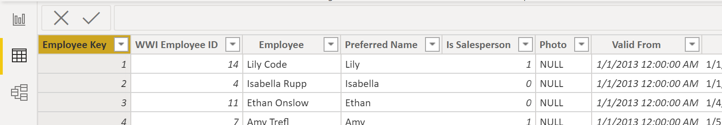

Switch to the Model view. You will see that the two tables are not connected.

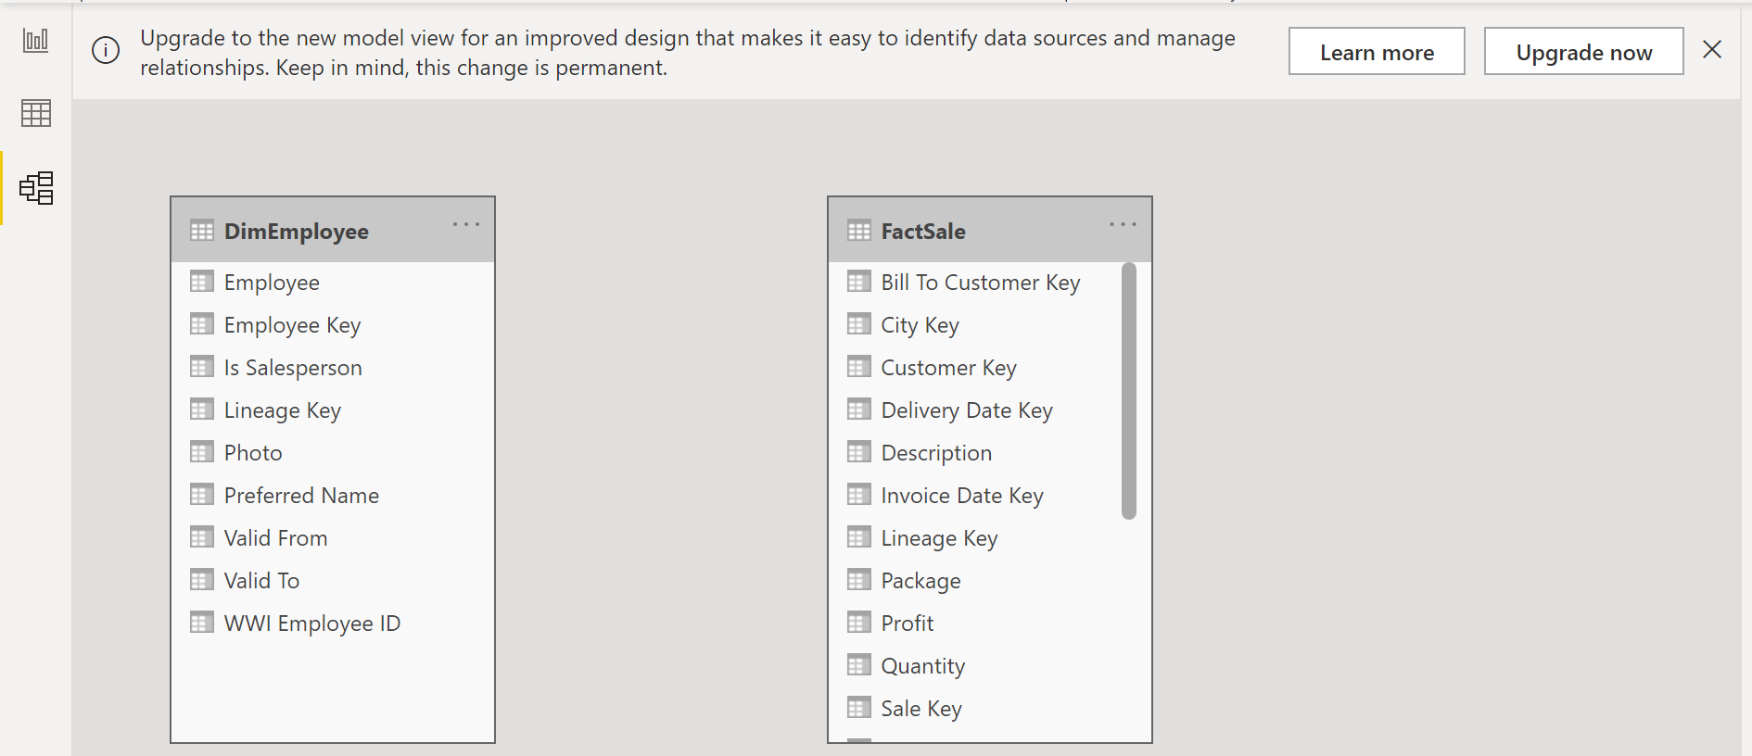



Create a connection between these two tables by dragging FactSales’s Salesperson Key to the Employee Key of the DimEmployee table. Power BI recognized that there is a one-to-many relationship between these entities.

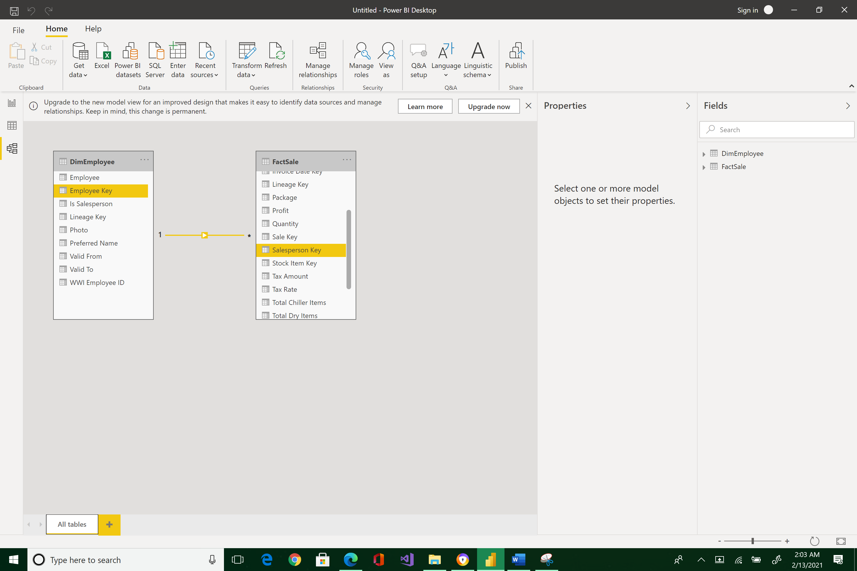

Now, go back to the Report view.

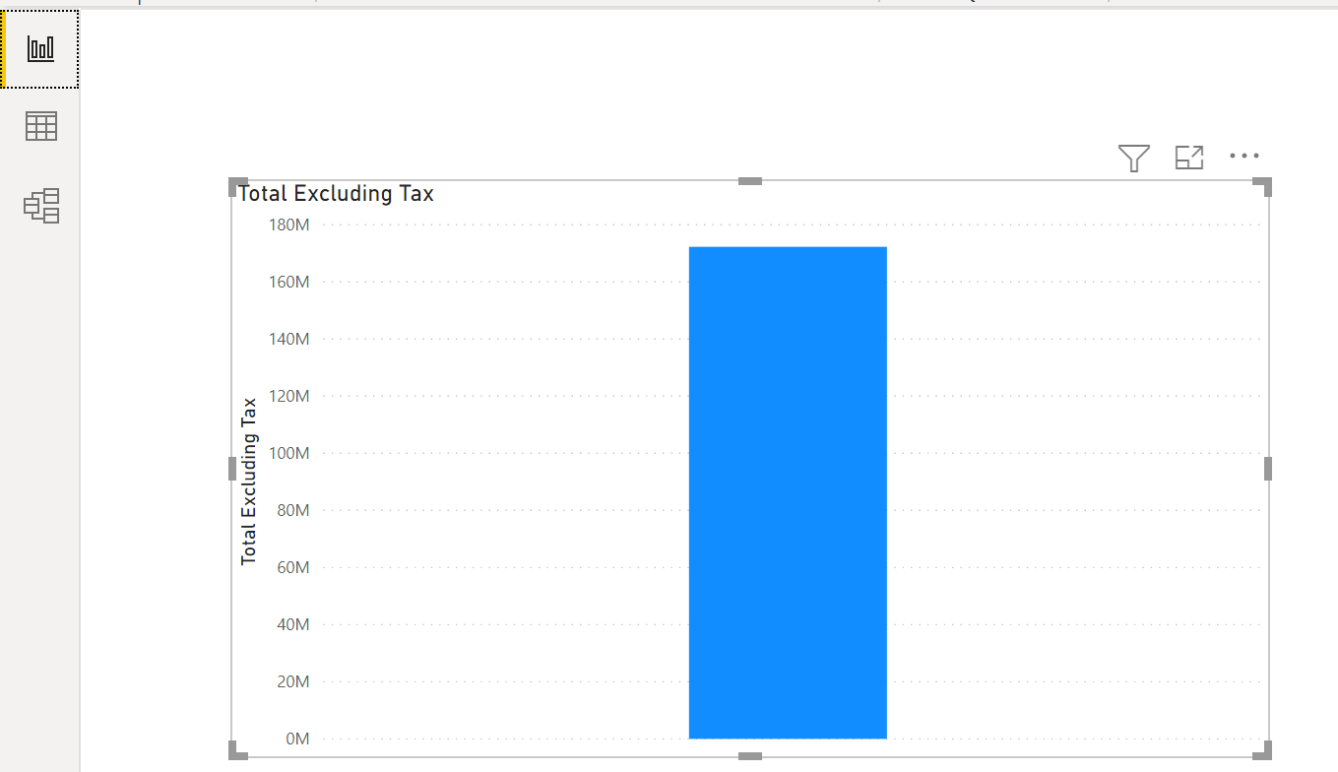



Add Employee to the graph by selecting the graph, and then the Employee field.

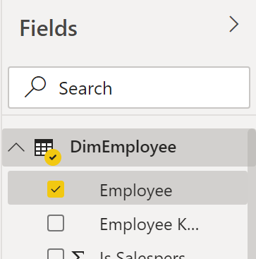 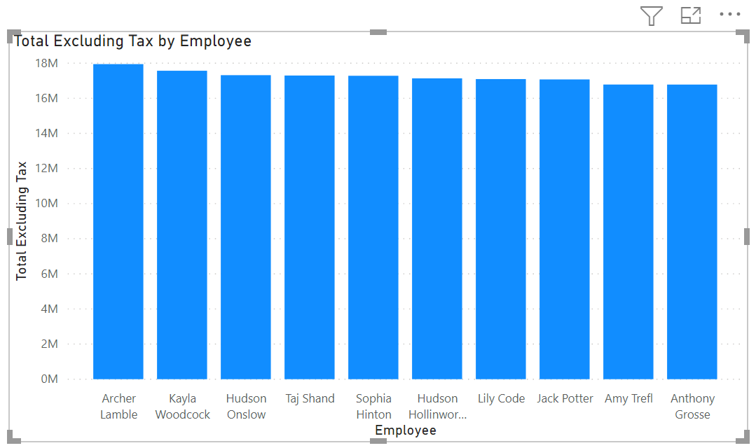



Power BI automatically adds the text field to Axis of the Visualization pane.

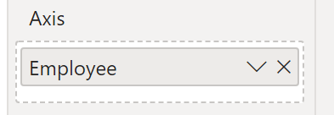

The bar graph now shows the sales each salesperson has generated rather than just the total sales. Observe how the tooltip changes its description as you hover your mouse into the different bars.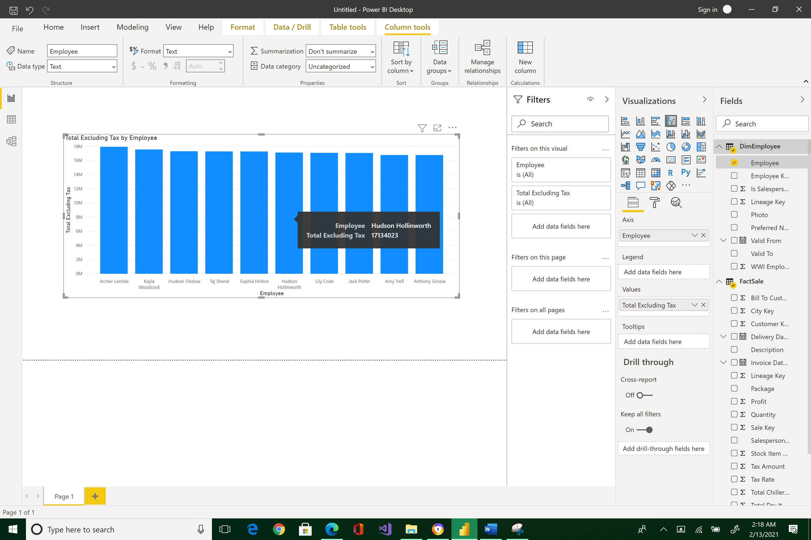



Now add a card visualization containing total sales excluding tax. To do that, click your mouse in a blank part of the Canvas area outside of the bar chart, then select card.

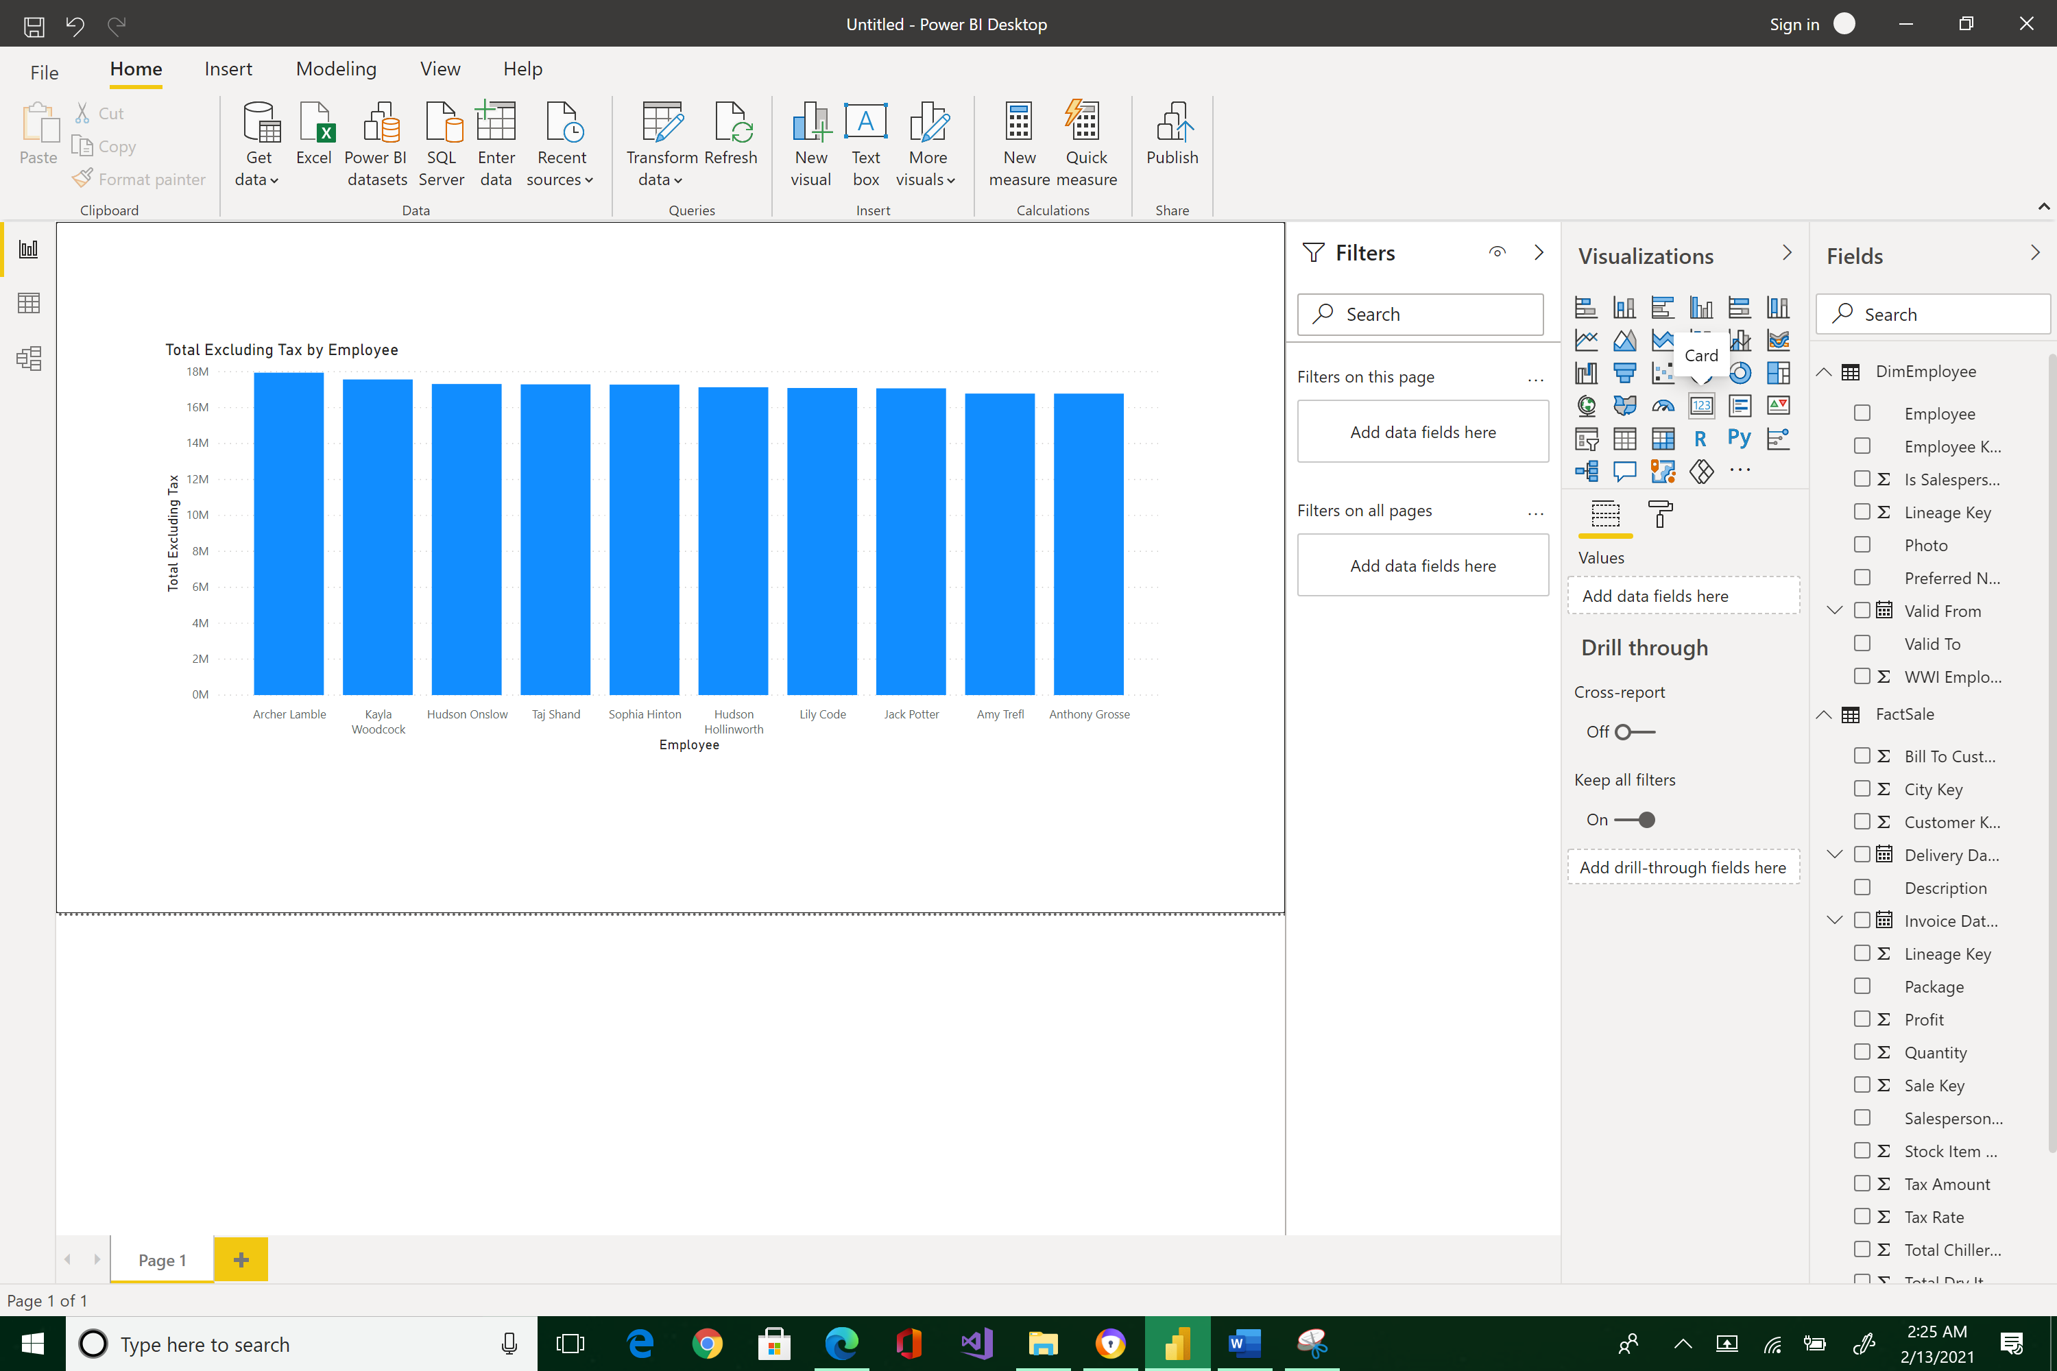



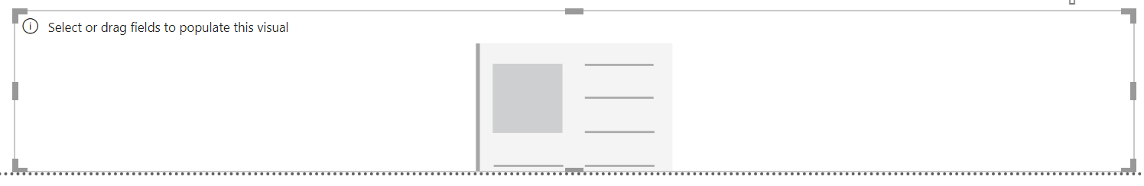

While the Card widget is the currently selected object, select Total Excluding Tax field.

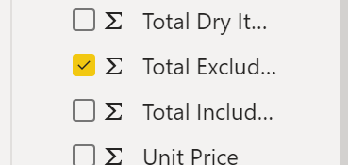 

Resize the card and arrange as shown below.

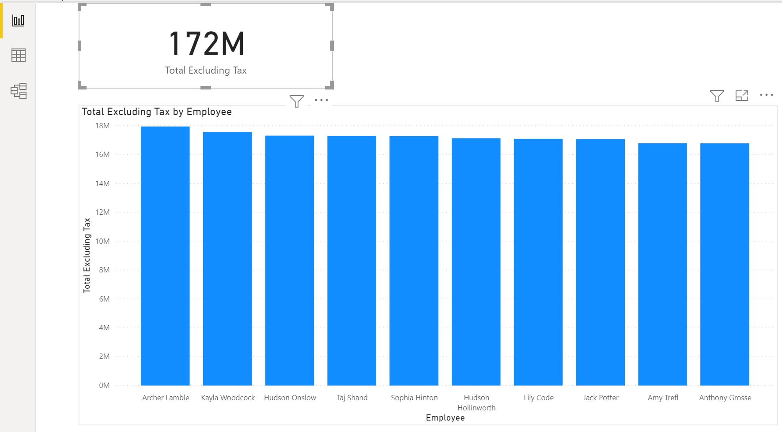

Take note of the total 172M.

Click on Lily to see her sales.

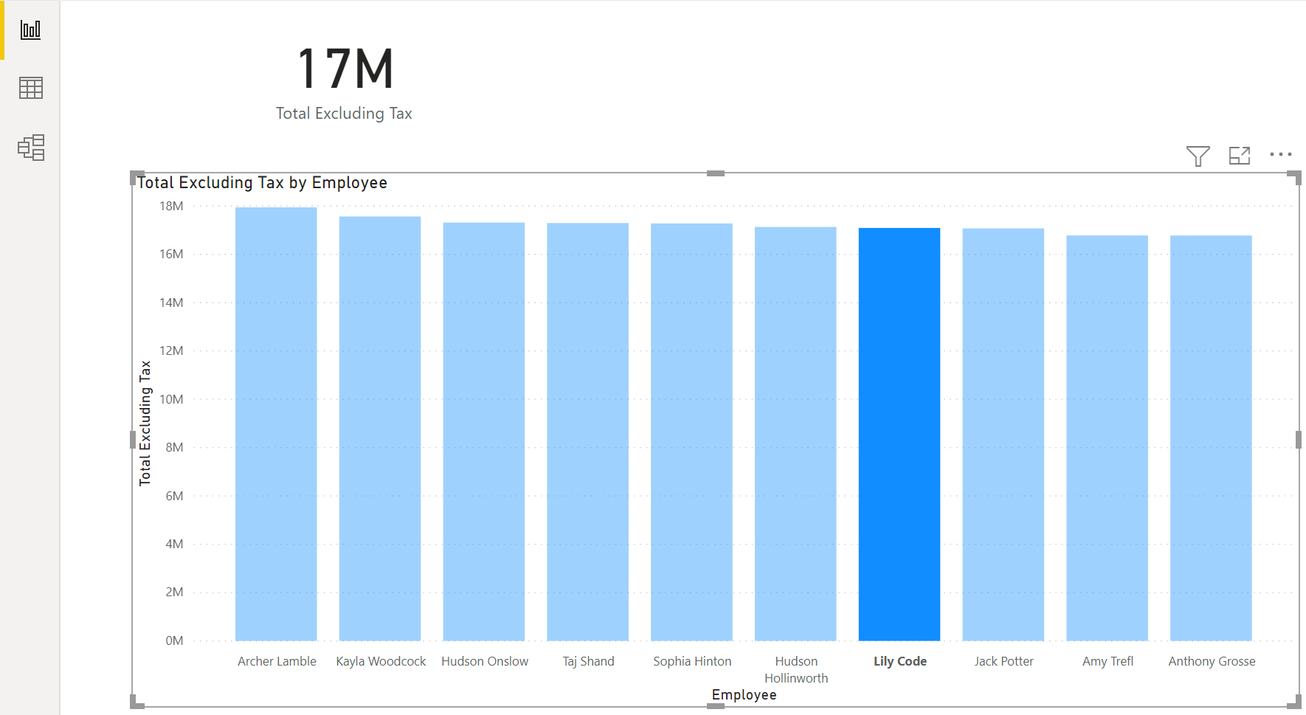

Click on any of the salespeople and watch how the total’s card value changes.

To display the grand total of all sales, click on any white space inside the bar region.

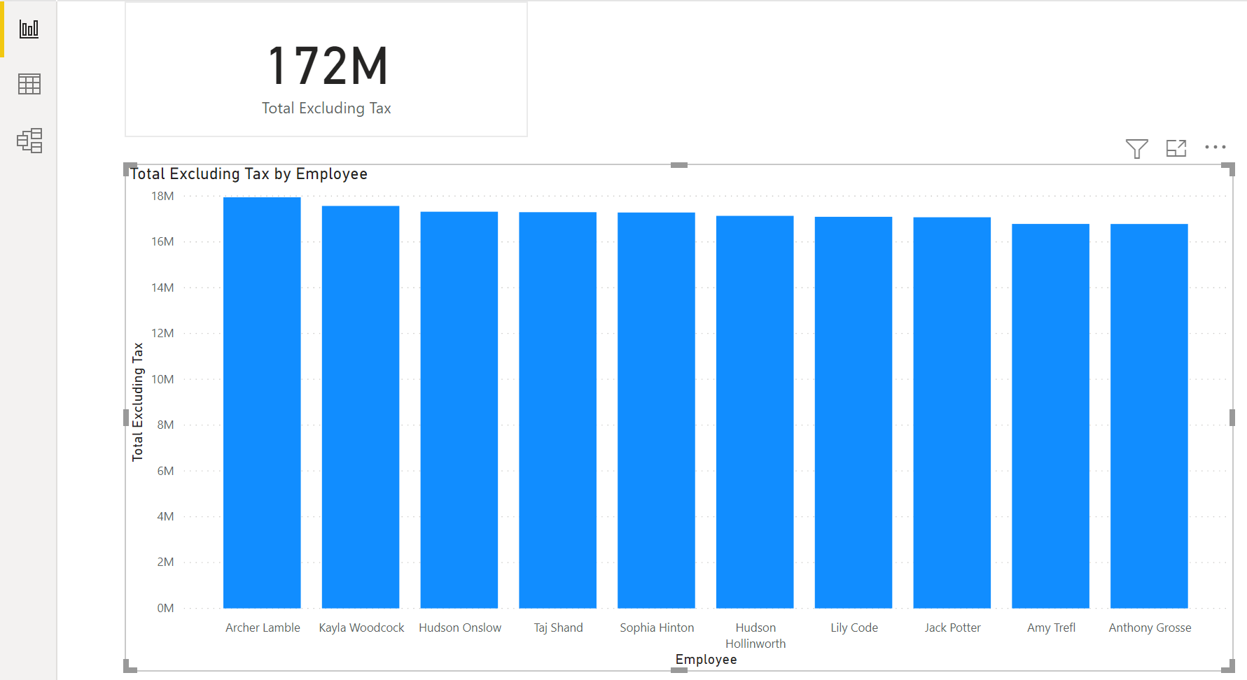



You can also change the visualization type by selecting the bar graph and trying out other visualization widgets. Select bar graph > click Treemap.

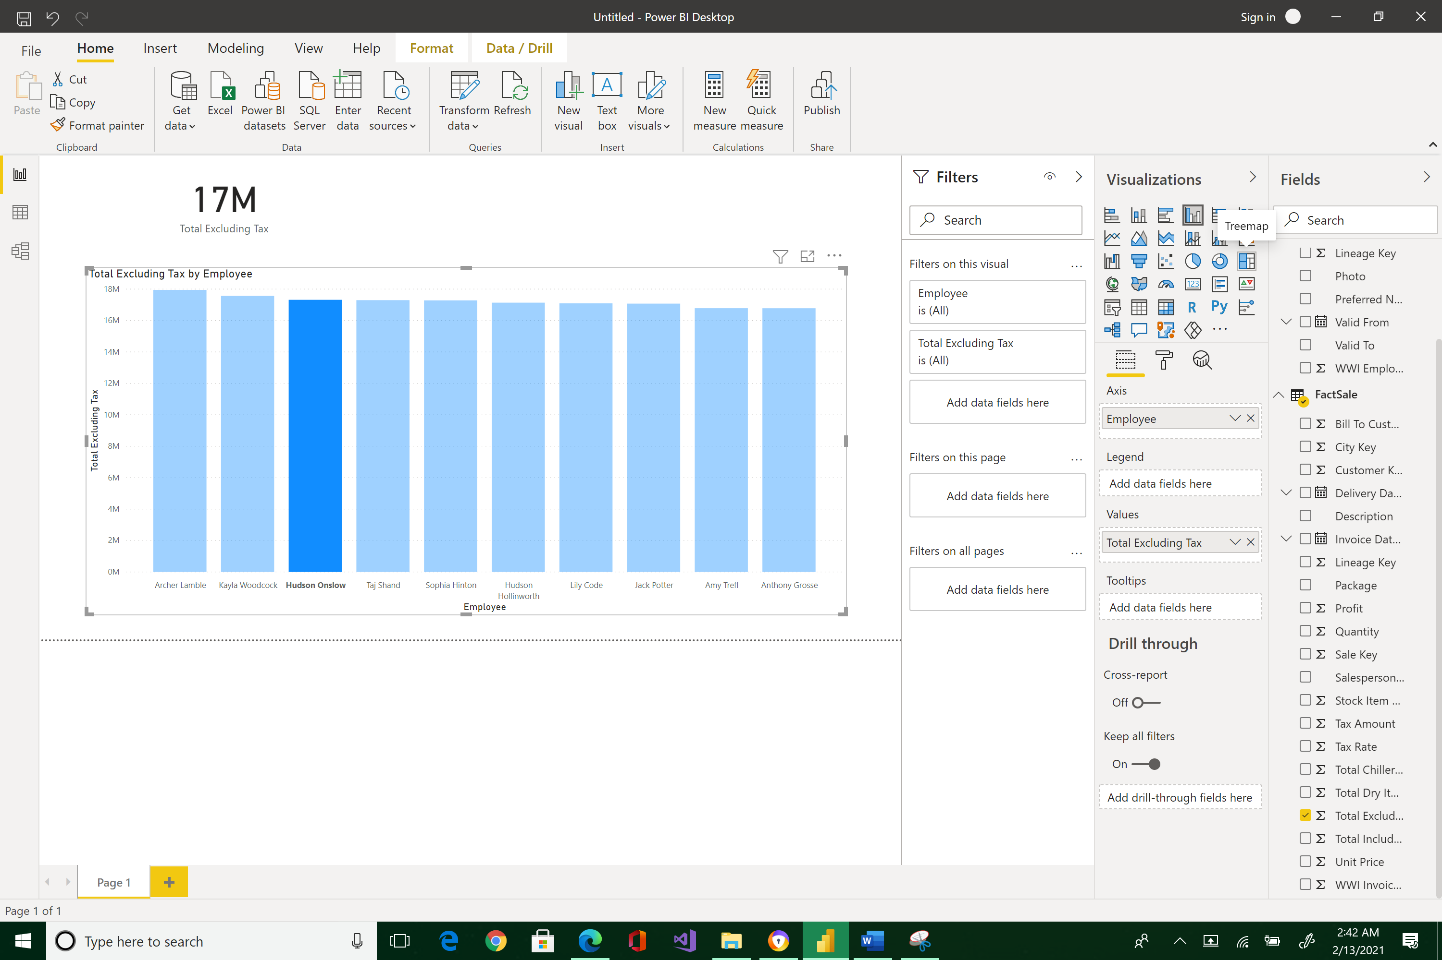 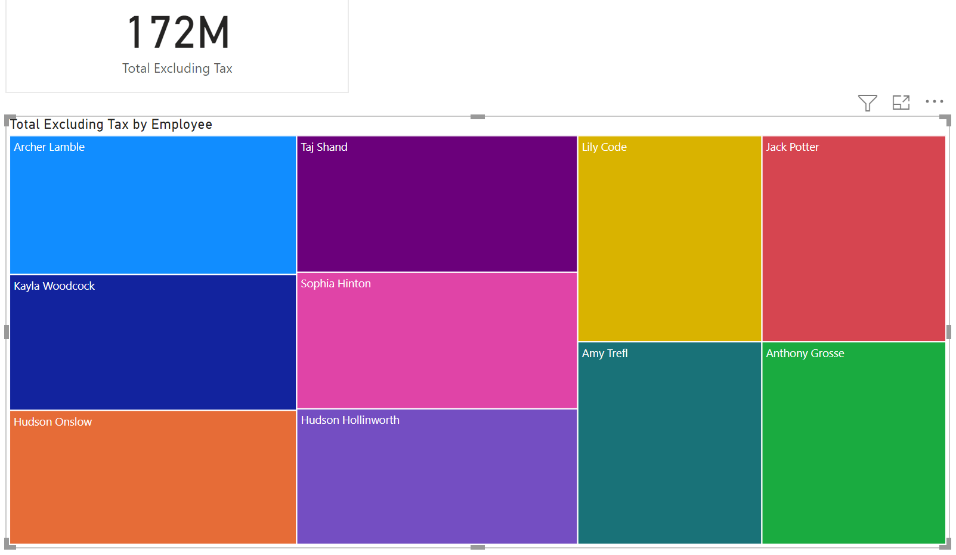



Or, a Donut chart

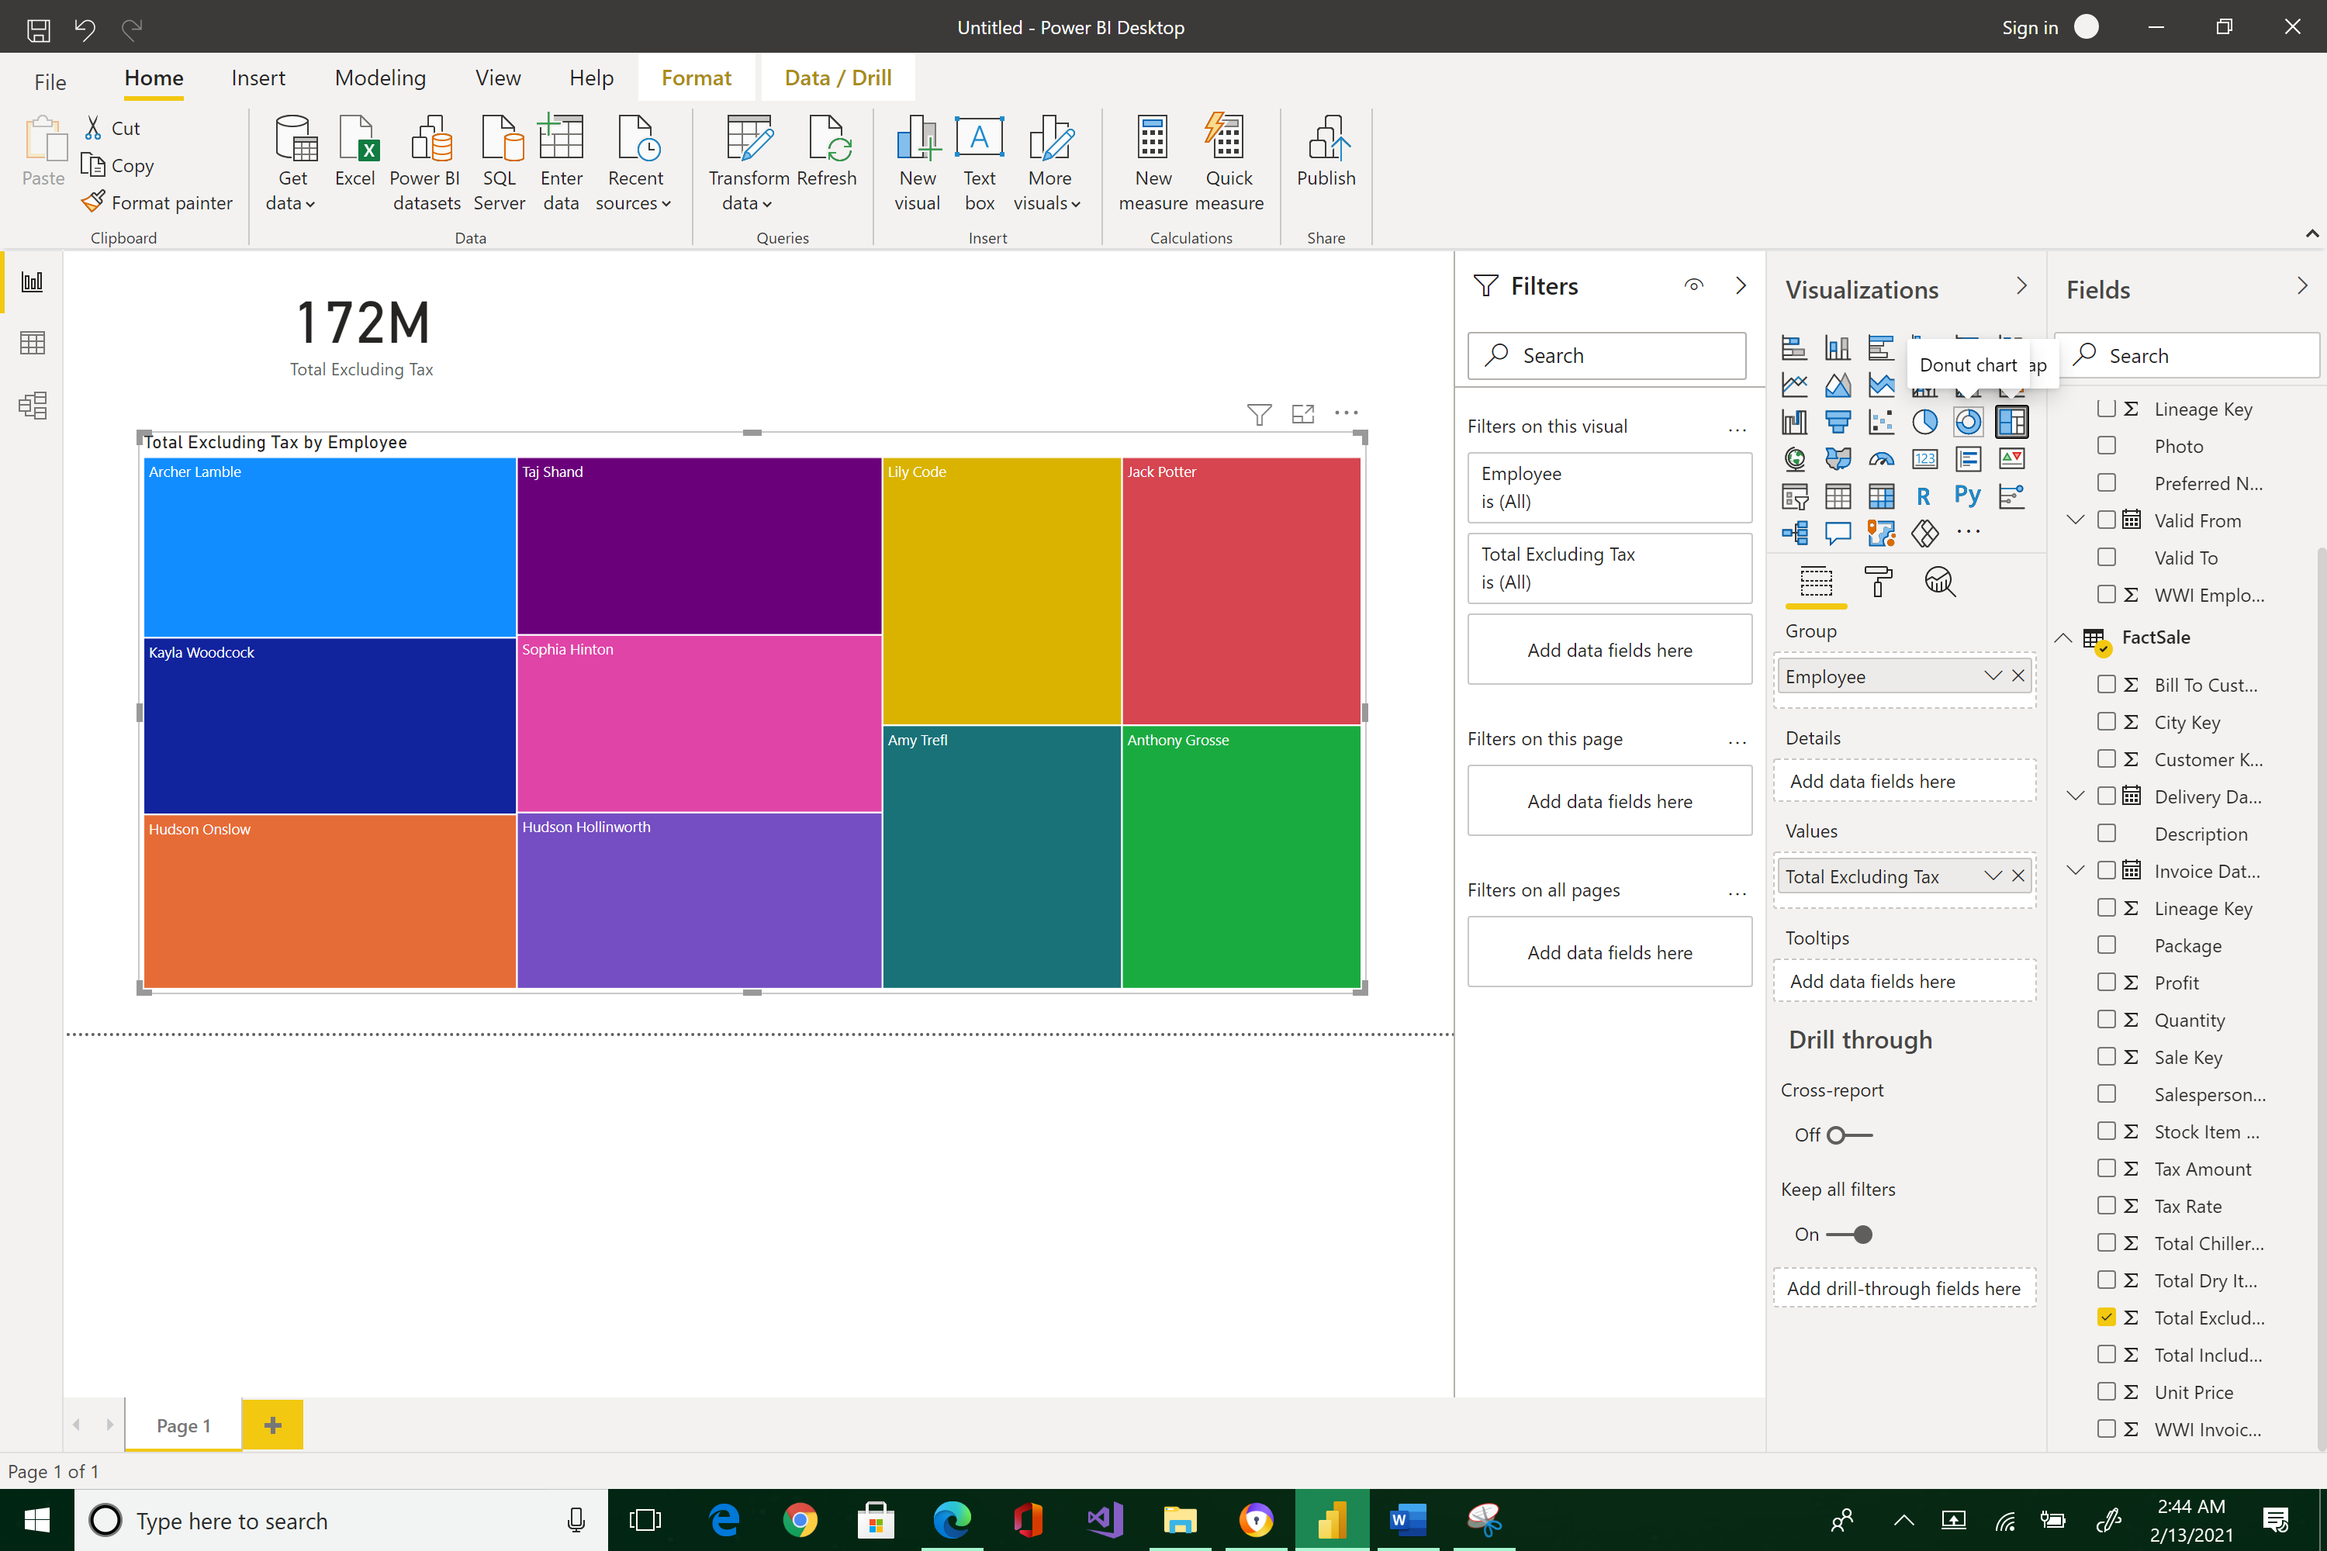 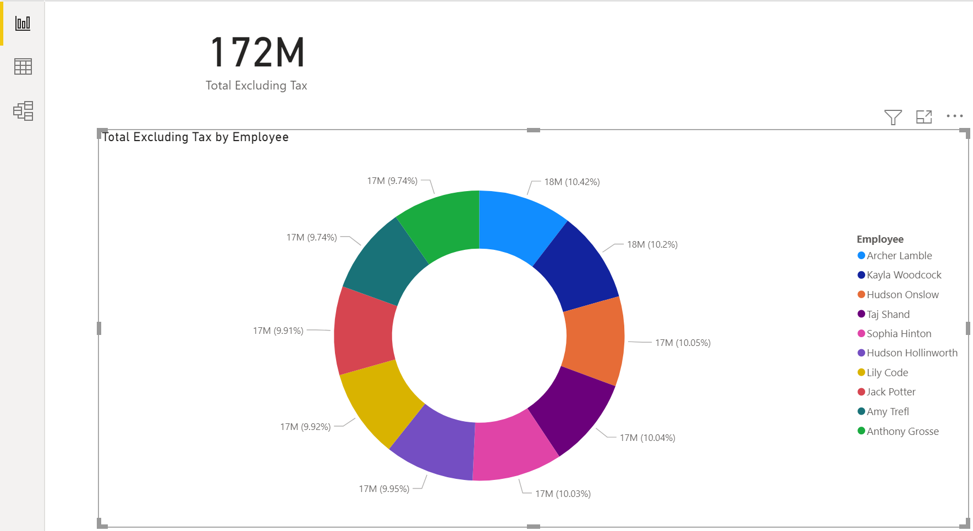



Save your pbix file on your Desktop using your name as the filename.

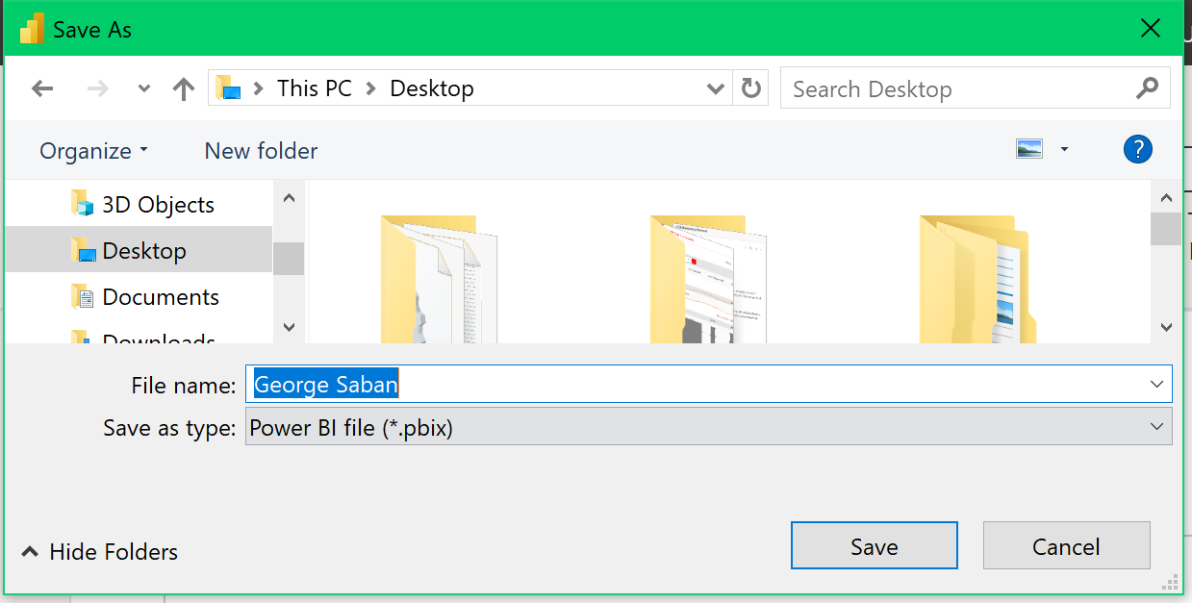



Please reposition your screen so that it would look like the image below. Take a snapshot using Window's Snipping Tool. Make sure the encircled items are included. Submit to Canvas in PNG format. Thank you!

